1. A) Inference: Top 10 Users who generate the most content share 16 percent of total content created.

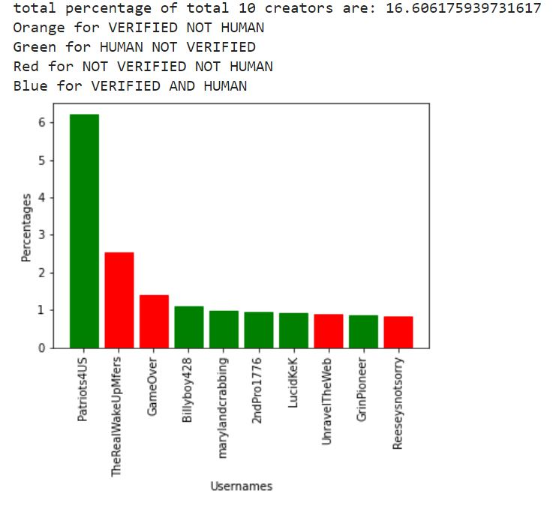

B) Inference: Six users are human but not verified, and four users are not verified, not human. None of the users is verified and human. Hence, it shows how fake information can be spread through bots or fake accounts.

1. A)

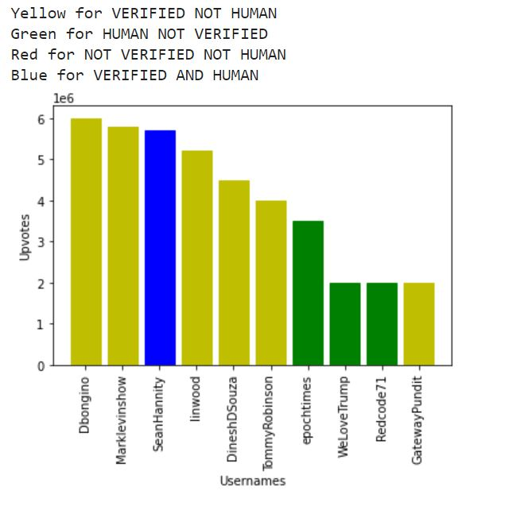



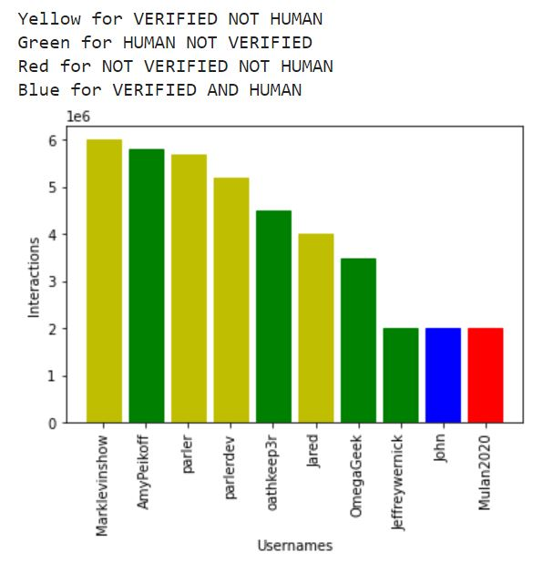

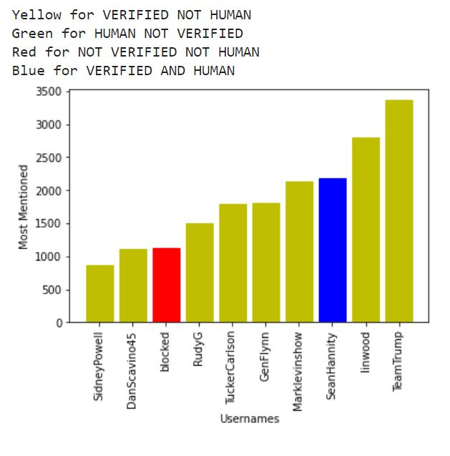

B)

WORD CLOUD:

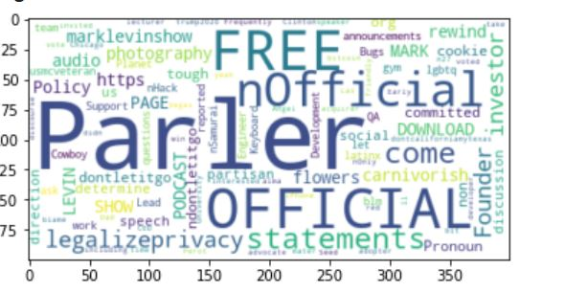

The above Wordcloud have words like Parler, official, founder, free, privacy, cookie, download. These are the words used frequently in the user’s bio.

This shows that for the top 10 users who interact, use parler word a lot and talk about official, privacy, statements.

There are also topics like podcast, mark, investor, which are used; hence we can infer that it is used for the podcast.

3)

a)

WORD CLOUD OF WORDS:

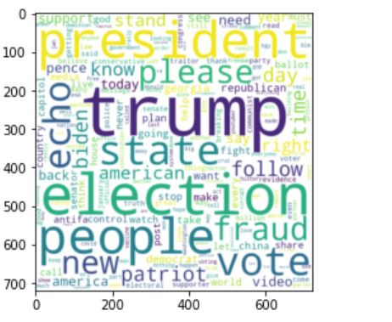

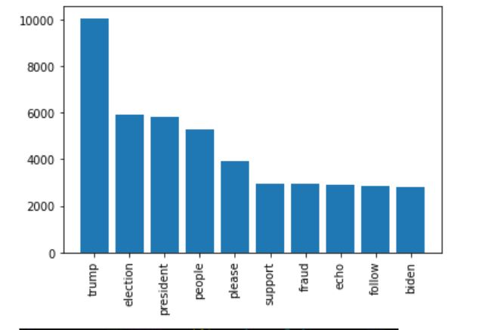

This plot shows the number of occurrences that Trump is discussed a lot more than Biden on social media about the presidential election in Parler social media.

It is also observable that Fraud and follow or support are also used by users, which shows that parler is used for campaigns for following and spreading the information about election fraud rumors due to which USA capitol Incident happened.

b)

i) PLOT BASED ON NUMBER OF OCCURRENCES:

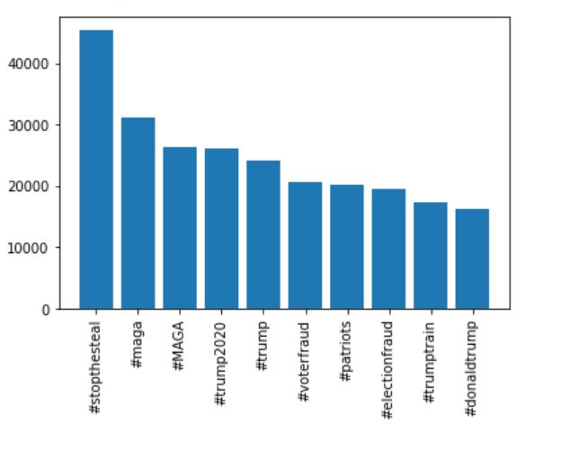

It is observable that stopthesteal is used the most and there are also hashtags such as MAGA(make America great again) and trump 2020 which gives a viewer a perspective that There is a lot of talks about Trump and elections regarding electionfraud.

ii)

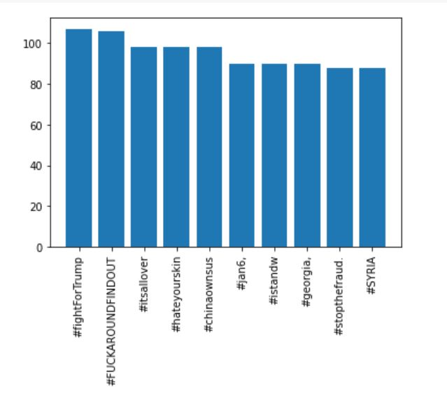

4)

a) It is observable that there was a massive increase in the number of posts on 6th January. It is seen that it was because of the US capitol hill incidents used to instigate protestors.

Various users post their opinions regarding the incident on social media whenever a significant incident occurs in the place and tell their opinions and thoughts to that person.

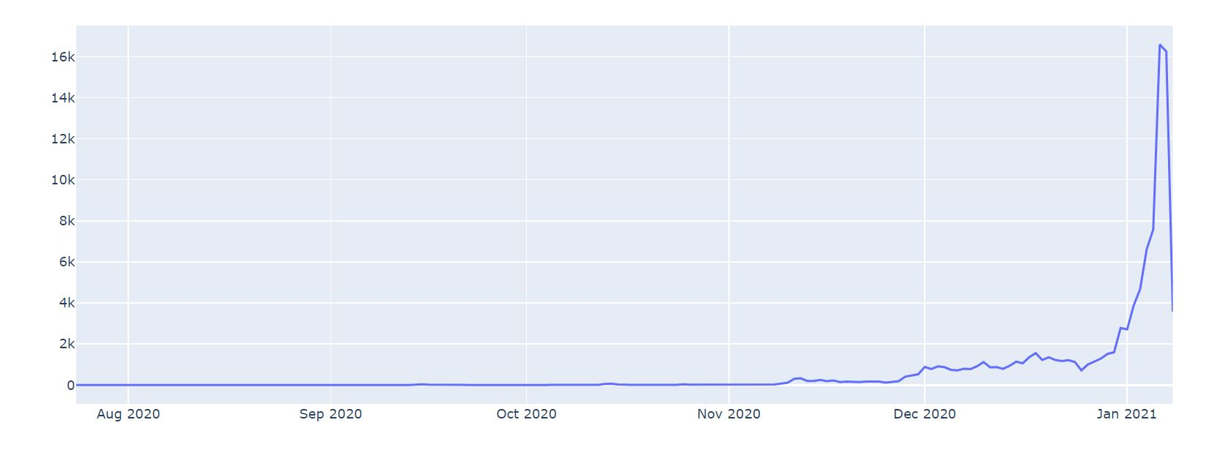

b)

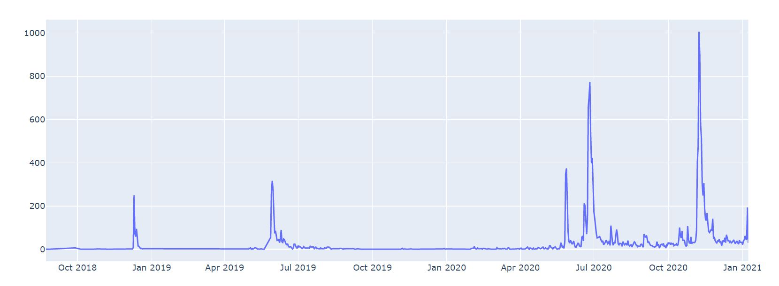

It is observable that user creation has been created for different people. This can be done by bots used for mass creation during special events for campaigns or spreading hate speech, especially during election season.

References:

<https://stackoverflow.com/questions/18973404/setting-different-bar-color-in-matplotlib-python>

<https://www.geeksforgeeks.org/generating-word-cloud-python/>